l

Foundations of Programming

Assignment No. : 01
- PROBLEM STATEMENT:
Write a program in C to check whether a given year is a Leap Year

OBJECTIVE:

- To understand the use of conditional statements in C programming.
- To implement logical conditions for solving real-world problems.
- To develop problem-solving skills using decision control structures.

THEORY:
- Theory for conditional statements with syntax (if , if-else, if-else ladder) are used in C programming
- Theory for a Leap Year - year that contains 366 days instead of the usual 365 days.
Rules:
• A year is a leap year if it is divisible by 400, OR
• A year is a leap year if it is divisible by 4 but not divisible by 100.
- Algorithm

Algorithm :
- Start
- Declare an integer variable year
- Ask the user to enter the year
- Read the value of year
- Check the condition
  - If year% 400== 0 → It is a leap year
  - Else if year % 4 == 0 AND year % 100 != 0 → It is a Leap Year
  - Else → It is Not a Leap Year
- Display the result
- Stop
Flowchart :
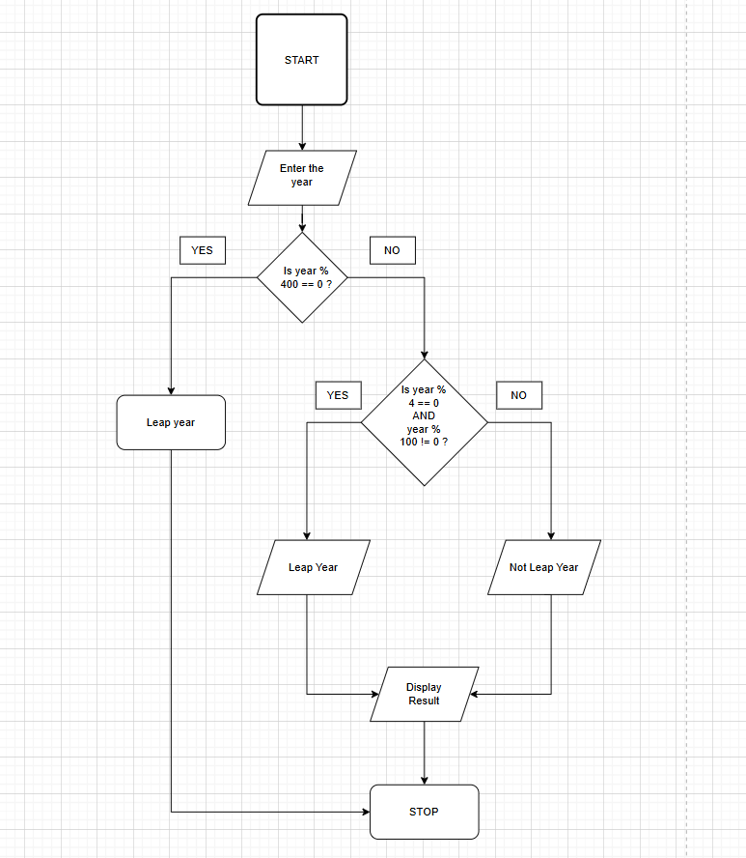

PLATFORM: Linux

CODE :
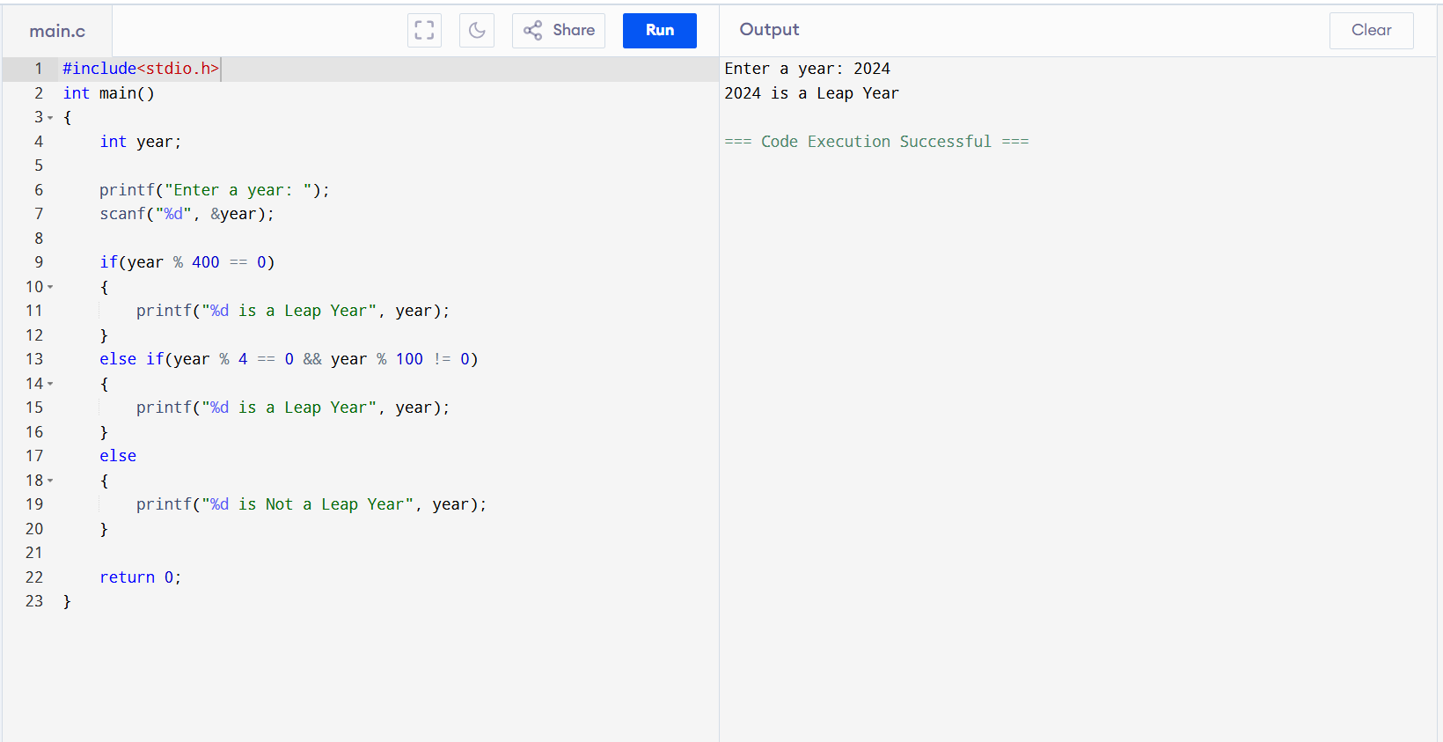

INPUT: Enter a year (integer value).
OUTPUT: Displays whether the entered year is a Leap Year or Not a Leap Year.
Sample Input
2024
Sample Output
2024 is a Leap Year
CONCLUSION: Thus, the program successfully checks whether a given year is a Leap Year using conditional statements in C.

FAQs:
- What is a leap year?
- Why is the year 1900 not a leap year but 2000 is?
- Which operators are used in this program?
- Difference between if and if–else statements.

